As a tower lead, contributed to

* **Organic growth** of Two towers in Verizon – Emerging Tech & Omnivoice / IVR – **200+ associates**
* **Jan to Dec 24 Revenue** is close to **11 million USD**
* **Client relationship** – Working with **6 Associate directors** ( each AD has two Senior managers/ Verizon PTL’s, close to **12 SM to be managed closely**) in Emerging tech and Omnivoice and managing client expectations , project work and escalations.Handling and resolving escalations, ensuring client feedback and recommendations are handled and managed internally
* **Acquired** new work through **New Tower** like System of Records, In Omnivoice new programs added like ConvolQ, Next gen IVR
* **Vendor governance & Reporting for** both towers.
* Ensuring detailed reporting through
  + Weekly Status Reports,
  + Vendor Governance Reports,
  + Sub task utilization reports,
  + Backlog and prod monitoring reports,
  + Sonar coverage reports
* **Ramp up and Team building** – Ensuring new talent is identified, screened, and positioned without any billing loss for all positions in Emerging tech and Omnivoice
* **SOW , Change Requests, new proposals** – Creation of Cognizant response documents, Change requests, Resouce loading, Customer profitability and new proposal documentation
* **Type 1 Milestone approvals** – Ensure all SLA based documentation is provided, review calls with clients are completed , necessary approvals are received and submitted for invoicing in field glass
* **Director + Team connects** – Ensure necessary decks are prepared and contributions are summarized and presented for D+ connects
* **Team building:** Regular interaction with each ACT teams to analyze the team strengths, skill gaps and motivating the team to do better.
* **Reduced attrition** by ensuring associates’ needs are also satisfied while giving them a proper growth plan
* **Building next in line leaders** to handle multiple ACTS, mentoring them for Client handling, project architecture, product understanding, upskilling and cognizant responsibilities
* **NO PCR** was given for Emerging tech from Jan 24 – Dec 24 for delivery related reasons
* **Extensive SLA** based delivery model **, 100% Say do Ratios, < 3 Prod defects per ER**
* **ACT Consolidation** – Ensured that KT and transition for onshore counterparts were completed on time and contribution started from Sprint 88
* **Large programs handled –** G2A Migration was one program which was on deep RED. Ensured planning and regular intervention , reporting to bring back the program on track. Though it had more EPS team, we had to face the client and ensure program with ala BAU components were migrated and new call flow applications were built and delivered with 80% throttling
* **Working on new rampups for ACT 300 –** Next gen IVR and **24/7 IVR prod and non prod model , New high visibility programs like ConvolQ**
* **SME Building –** All towers are planned for leads, next in line leads and SME building to ensure flawless delivery
* **Omnivoice –** Ensuring delivery of Inbound, Outbound, G2A, SRE , non prod support , monitoring, IVR apps
* **Emerging tech –** Ensuring delivery of Chat contain , CPC, Sales, programs like Disney bundle, Youtube tv, HEET, tanglewood programs got delivered without issues
* **Agent Assist –** Critical contribution for Personal research Assistant , Message, Voice and FIOS Messaging assistants
* **Emerging Platforms –** Ensuring platform related applications and enhancements, analytics issues identification and automation needs were delivered
* **Omnivoice Delivery**
  + Story Points -  5000+ Q1- Q4
  + Say do Ratio -  > 95% for Type 1 ACTS
  + DES Survey – 100%
  + Marvel Score - AAAA
  + Application Risk Scores: Well within Risk Appetite
  + In sprint Automation integrated with Cyara testing
  + Sonar Coverage 70 to 80%
  + Prod Defects : < 3 defects in each sprint( type 1 ACTS)
  + Upskilling Initiative for associates :
    - Spring Reactive
    - Grafana to Kubernetes Dashboard
    - AEM & GDF trainings

**Emerging tech Delivery**

* + Story Points -  5910 ( Type 1 ACTS alone)
  + Say do Ratio -  > 99% for Type 1 ACTS
  + DES Survey – 100%
  + Marvel Score - AAAA
  + Application Risk Scores: Well within Risk Appetite
  + In sprint Automation - > 50%
  + Total Regression TC Automated : 3915
  + Regression TC Automation -> 80% to 90% automated
  + Sonar Coverage : 90% overall & 95% new code
  + Prod Defects : < 3 defects in each sprint( type 1 ACTS)
  + Upskilling Initiative for associates :
    - Spring Reactive
    - Gen AI , prompt Engineering , Google Gemini
    - AEM & GDF trainings
  + Subtask Automation improvement
  + CXP upskilling to handle CXP issues
  + Address backlog tickets and KPI improvements

Apart from the above , I have contributed to several initiatives in the past

* Worked with our Verizon leaders for **Client visits** – Sudharshan
* Worked with Comm tech leaders for **Other accounts** - Charter client visit planned 5 times in 2025
* Technical sessions conducted for the Verizon **Outreach programs**
* **Symposium**: Industry leader and presenter in SSN Symposium
* Contributed to **blockchain syllabus creation** for Sathyabama university along with HR
* Conducted Emerging tech demos to Consulting teams at onshore
* **New talent identifications**- Freshers and Lateral hirings , interviewing and feedback
* **Supervisor level activities** – Goal setting, Review for employees, VISA , promotions etc
* **Project level Activities** – ESA Management, Delivery Excellence  , Business continuity planning etc
* **Completed upskilling Google CCAi, Gen AI** – Python, Google gemini etc
* **Proposals Worked**
  + - Disney Account – Go lang estimates
    - Verizon Design COE RPA Governance RFP
    - Change Requests and SOW for Omnivoice and Emerging tech
    - Chatbot experience & improvement – with Consulting leads like Gao Ning ( Onshore)
* Helped with redefining Architecture issues in Value program . Suggestions provided from my end
* Prior to VCG, I have worked 3 + years in CSG Portfolio as a **Blockchain Architect and Managed delivery** of all blockchain programs for Verizon

PFB the feedback from Ahmed Khan, Director onshore , Blockchain Delivery

**From Verizon Director**

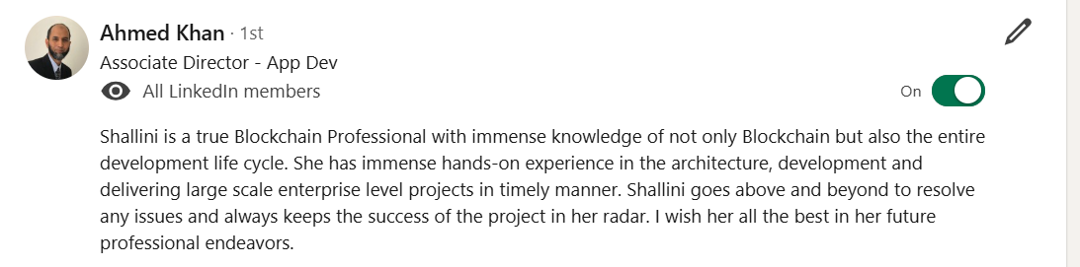

**From CTS D+**

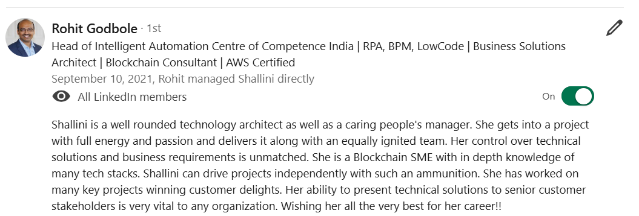

**Rajiv Rajasekaran, EDL , Comms Media**

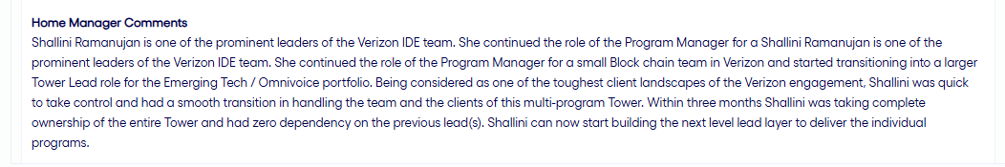

**From CTS SD+**

